1. What is a Partnership?

A partnership is when 2 or up to 20 people join a business. This is to share the workload and add more capital to the business; this in turn can improve the business as more money is put in and the workload is split across all the workers.

1. What are the advantages of setting up a Partnership business?

There is more capital in the business so there is more money, as there are other members they can pitch different ideas, you can then share the workload between each member, one of these members may already have previous experience in these sectors, and you may get limited liability.

1. What are the disadvantages of setting up Partnership business?

You may disagree on some decisions made, which might then take longer decide on a happy medium, you are responsible for all actions made by both you and your partner and you share the profits with your partner.

1. Name a “Partnership” that you are aware of and find two images of this from the internet.

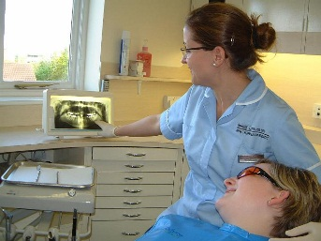John G Plummer & Associates:

1. Describe the Purpose of the business:

To make money from the amount of people who use private and the NHS dental care.

1. Describe the Activities of the business:

The business provides dental care on the NHS.

1. Describe the Ownership: This is a professional Partnership.
2. Describe the Size and Scale: The size of this is small as there are less than 99 employees, and a small scale as they have to do everything in their building so everyone has to go to them.
3. Describe the Links between ownership size and scale: This is a small business with small size and small scale.
4. Describe the sector is it in and why? This is in the tertiary sector as it provides care for people.